Week 3
Software Engineering Lab
23BCE1935
Annuj Kumar

Use Case Diagram ( UML Diagram using StarUML )

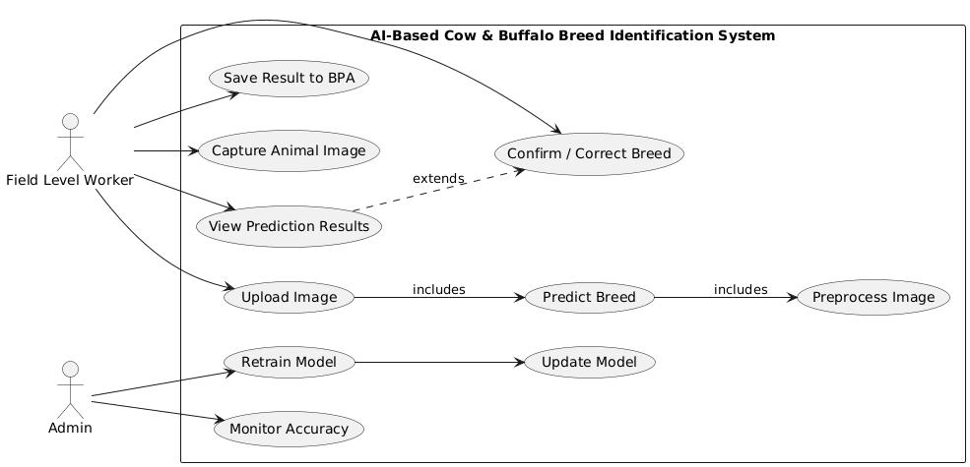

Class Diagram ( UML Diagram using StarUML )

